

Media contact: Heather West, 612-724-8760, heather@heatherwestpr.com

Photos by: Marilyn Ott-Close

Wausau’s windows present Page County High School students, teachers, with picture-perfect views

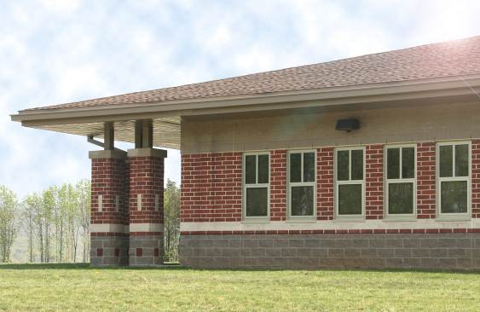
Wausau, Wis. (Aug. 2010) -- Students, staff and visitors to the new Page County High School enjoy unrestricted views of their picturesque surroundings, thanks to Wausau Window and Wall Systems.

Located in the Shenandoah Valley community of Luray, Va., the new building serves 750 students in grades 9-12. Designed by Fanning/Howey Associates, Inc., to accommodate the area’s growing population, the building includes a cafeteria/food service facility that easily can be expanded, and an auxiliary gymnasium/wellness area that provides an immediate, much-needed community recreational facility, as well as future opportunity for additional physical education space.

Nielsen Builders, Inc., managed the construction of this $25.5 million project, completed in May 2009. Working closely with Nielsen, specialty glazing contractor Glass & Metals, Inc., of Harrisonburg, Va., selected Wausau’s 4250 Series windows for the project. Part of the Advantage by Wausau® line of competitively priced, high-performance, standard products, the 4250 Series windows meet the energy-efficiency concerns and fast pace of construction timelines for buildings such as schools and universities.

For Page County High School, more than 185 fixed and operable windows were installed, providing students and teachers with daylight, outside views and natural ventilation. The window systems’ low-E glass and 5/8-inch integral blinds help control solar heat gain, while allowing natural light to flow into classrooms and other learning spaces. Multiple studies have shown that exposure to daylight positively affects employee morale, improves student health and raises test scores.

Contributing to schools’ green goals, all Wausau products meet the industry’s most stringent requirements for air infiltration, water resistance and structural integrity. Wausau’s 4250 Series windows are backed with up to a 10-year limited warranty, one of longest and most comprehensive in the industry. These units feature a polyurethane thermal barrier and are rated as AAMA AW-70 Performance Class. They also are labeled by the National Fenestration Rating Council for energy performance.

Further enhancing the school’s performance, lowering maintenance and extending longevity, Wausau’s 4250 Series windows’ 4.5-inch-deep aluminum frames were finished by Linetec with a durable, VOC-free anodize. The company’s new, eco-friendly anodize presents a ‘frosty’ matte finish, improving surface uniformity, and making it an ideal choice when specifying Wausau’s products with high recycled content secondary billet.

(more)
Today, Wausau fabricates all of its products using aluminum extrusions exclusively from secondary billet that contain at least 70% total recycled content. Combining recycled content and durable finishes with the windows’ thermal performance, daylighting advantages and natural ventilation may aid buildings seeking certification under such programs as the LEED® Green Building Rating System™.

Page County High School, Page County Public Schools, Luray, Va.
- Owner: Page County Public Schools, Va.
- Architect: Fanning/Howey Associates, Inc., Shenandoah, Va.
- Contractor: Nielsen Builders, Inc., Harrisonburg, Va.
- Glazing contractor: Glass & Metals, Inc., Harrisonburg, Va.
- Glazing systems – manufacturer: Wausau Window and Wall Systems; Wausau, Wis.;
www.wausauwindow.com
- Glazing systems – finisher: Linetec, Wausau, Wis.; www.linetec.com

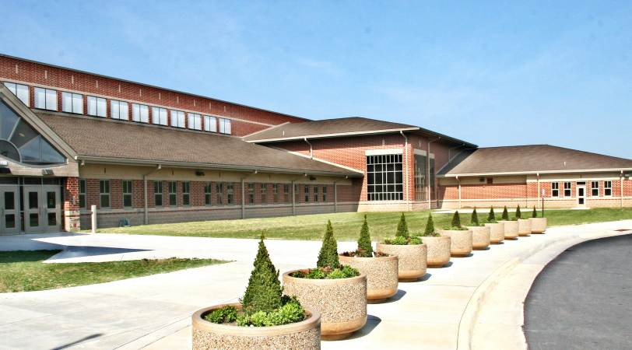

To learn more about Wausau’s school success stories and window products for educational facilities, please visit http://www.wausauwindow.com or call 877-678-2983.

Nationally recognized for its innovative expertise, Wausau Window and Wall Systems is an industry leader in engineering window and curtainwall systems for commercial and institutional construction applications. For more than 55 years, Wausau has worked closely with architects, building owners and contractors to realize their vision for aesthetic beauty, sustainability and lasting value, while striving to maintain the highest level of customer service, communication and overall satisfaction. Wausau is a part of Apogee Enterprises, Inc., a publicly held, U.S. corporation.
###

