
Media contact: Heather West, 612-724-8760, heather@heatherwestpr.com

Wausau wins Wisconsin Corporate Safety Award

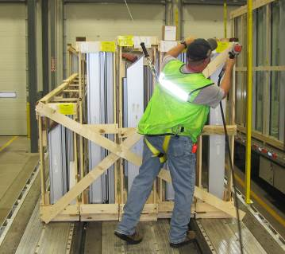
Wausau, Wis. (May 2014) -- After being honored five years in a row as an award finalist, Wausau Window and Wall Systems has been selected as one of only 13 winners in the state of the prestigious, 20th annual Wisconsin Corporate Safety Award.

Nominees for the Wisconsin Corporate Safety Award submitted safety data and a report describing the company’s occupational safety and health practices. “Every member of our team helped achieve this award through their daily focus and personal ownership of safety,” said Brian Vanden Heuvel, Wausau’s vice president of operations. “At Wausau, our safety-based culture is an essential part of everything we do. It’s wonderful to be recognized for this integral aspect of our company.”

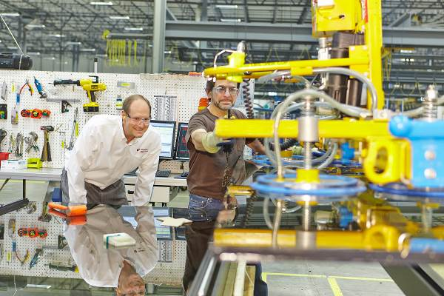
As stated on the Wisconsin Safety Council website, “This awards program honors businesses for exemplary safety records and excellence in safety and health management. These businesses are making safety a top priority. They have gone to extensive measures to assure their most valuable asset -- their employees -- are safe on the job.”

“Creating a safe and enjoyable work environment is a Core Value at Wausau, and supports our mission to maintain industry leadership in value, quality, service and reliability,” said company president Jim Waldron. “Our employees are dedicated to achieving this mission and to living these Core Values each and every workday. We are very proud of our entire team for earning this honor.”
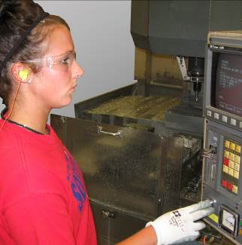
Further contributing to the morale, health and safety of its employees and community, Wausau’s manufacturing facility was designed and built to meet the U.S. Green Building Council’s LEED® Silver level certification for energy and environmental leadership. Multiple studies have documented measurable benefits for improved daylighting, natural ventilation and indoor air quality in buildings including reduced illness and absenteeism, and productivity gains of up to 16 percent.

To learn more about Wausau’s safe, green business practices, products and tools, please visit
http://www.WausauWindow.com.

Nationally recognized for its innovative expertise, Wausau Window and Wall Systems is an industry leader in engineering window and curtainwall systems for commercial and institutional construction applications. For more than 55 years, Wausau has worked closely with architects, building owners and contractors to realize their vision for aesthetic beauty, sustainability and lasting value, while striving to maintain the highest level of customer service, communication and overall satisfaction. Wausau is a part of Apogee Enterprises, Inc., a publicly held, U.S. corporation.

Wausau and its staff are members of the American Architectural Manufacturers Association (AAMA), the American Institute of Architects (AIA), the APPA – Leadership in Educational Facilities, the Construction Specifications Institute (CSI), Glass Association of North America (GANA), the National Fenestration Ratings Council (NFRC) and the U.S. Green Building Council (USGBC).
###

