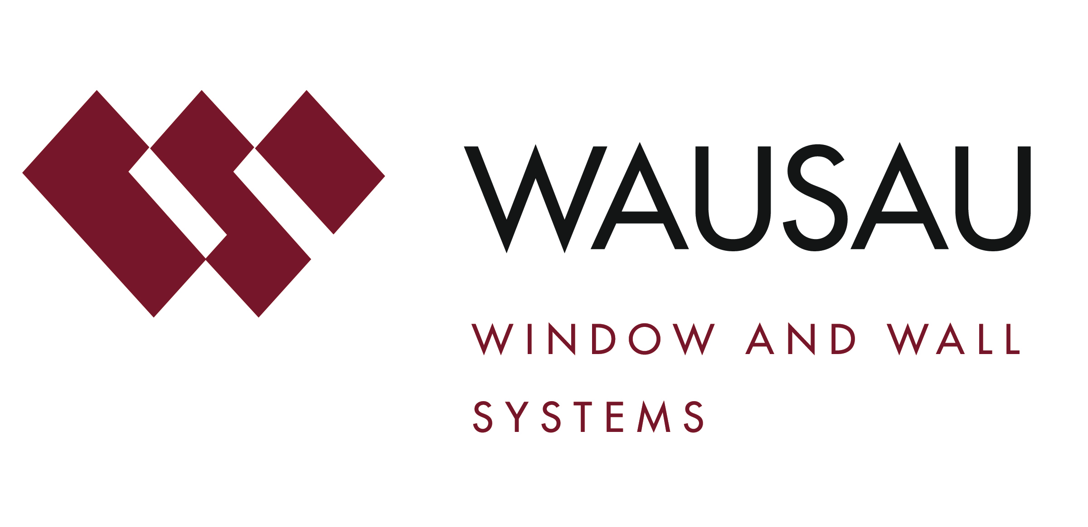
Media contact: Heather West, 612-724-8760, heather@heatherwestpr.com

Photos by: Joshua Jay Elliott, courtesy of Works Progress Architecture, LLP

Slate, Portland’s new, LEED Gold, mixed-use, transit-oriented development, features Wausau’s windows, doors and curtainwall

Wausau, Wisconsin (June 2017) – The City of Portland, Oregon’s new 10-story, mixed-use, transit-oriented development known as Slate earned LEED® Gold certification through the U.S. Green Building Council in Dec. 2016. Formerly called Block 75, the high energy-efficiency building features window, entrance and unitized curtainwall systems by Wausau Window and Wall Systems.

A cornerstone in the City’s efforts to revitalize the Burnside Bridgehead area, Slate rises on a previously vacant lot. Opened in Sept. 2016, the project spans 147,000 square feet and offers 75 market-rate apartment units on the upper six floors; 35,000 square feet of creative co-working office workspace on floors 2-4; and 7,800 square feet of retail space at street level.

Designed by Works Progress Architecture for co-developers Urban Development Partners and Beam Development, the property conveys a “push and pull” theme exemplifying the location’s vibrancy. The glass, metal and concrete façade consists of articulated, modulated, rectangular shapes, including some that are setback and some that project over the sidewalks below.

“It creates the illusion of a shifting stack,” describes Works Progress Architecture’s Ian Roll. “On the North and South sides, the curtainwall has a flat, clean, crisp look that transitions to a sculpted, figural texture on the East and West elevations. The curtainwall is crucial in registering the intentional lines and visual elements.”

Roll notes that the firm worked closely with Wausau Window and Wall Systems from the project’s earliest stages. He credits Wausau’s architectural sales representative Brad Glauser as his primary contact in working through the project’s complexities.

“Brad assisted us with selecting the system, and fine-tuning it to achieve the building envelope’s glassine openness and meet the energy code,” says Roll. “With digital modeling, we were able to get inside the units before anything was built to balance where the glass and metal panels should be placed for the right performance and look.”

Bringing the architectural vision to reality, Yorke & Curtis, Inc. served as the general contractor. They broke ground in Jan. 2015 and coordinated the phased construction schedule with Oregon-based glazing contractor Dallas Glass.

Dallas Glass began installing Wausau’s products in April 2015 and was substantially completed by Jan. 2016. Wausau Window and Wall Systems provided more than 40,000 square feet of INvision™ 7250i-HRX SSG Series unitized curtainwall and 7250 Series SuperWall™; 240 project-out awning 4250Z zero sightline windows; and 4250i-TD Series terrace doors and D5100 Series sliding patio doors.

This project was the glazing contractor’s first experience with a unitized curtainwall system. “We loved it,” says Darand Davies, president of Dallas Glass. “I think it went really well for being our first time working with a unitized system. It was rather amazing that, on average, we have just five guys in field who were capable of completing a full floor every two weeks.”

“Using INvision unitized curtainwall, installation time is a fraction of what’s necessary for field-glazed systems. Handling for each unit is minimized, which decreases the opportunity for a mishap and saves time overall,” notes Wausau’s Glauser. “The curtainwall’s interlocking frame design accommodates seismic, live load and thermal building movements. Low U-Factors allow broad expanses of vision glass to meet Model Energy Codes.”

To match Portland’s climate and the project’s goals for energy efficiency and occupant comfort, Wausau’s aluminum-framed products have been thermally improved by Linetec using a polyamide barrier. Combining the thermal barrier with solar-control, low-e, insulating glass achieves the specified performance for low solar heat gain coefficient, low U-Factor, high condensation resistance factor and high visible light transmittance. Seasonal opportunities for natural ventilation also help reduce the demand on HVAC systems and associated energy use. Weather permitting, the operable windows on Slate allow tenants to enjoy fresh air, natural light and views.

Within sight are downtown Portland, the Willamette River, landmark bridges, the West Hills and Mount Hood. According to the City of Portland’s Design Commission, Slate’s design features floor-to-ceiling curtainwall “placed at the most important – in other words, the most visually prominent and functionally significant parts” and “aids in the success of the space by fostering a visually seamless relationship between the building’s interior and the exterior environment.”

“Transmission of unwanted noise is reduced by heavy architectural glass and low air infiltration,” adds Glauser. “Along with the great location and comfortable interiors, tenants also are drawn to the building’s attractive appearance. And building owners and property managers will appreciate the ease in maintaining the window systems’ appearance and functionality.”

Contributing to the low-maintenance and durability, the aluminum frames on Wausau’s products were manufactured with an average of 74 percent recycled content and finished by Linetec in a Dark Bronze anodize. Linetec also finished the matching aluminum panels supplied by Firestone. The aluminum panels and frames, and bronze-toned and clear glass, were factory-fabricated as a unitized curtainwall helping ensure the intended appearance and performance, and to simplify and accelerate their installation.

“The building adheres to a carefully considered, cohesive, unified design concept that promotes the building as a bold, permanent fixture of the Burnside Bridgehead, the larger Central Eastside Subdistrict, and the larger Central City Plan District,” concluded Portland’s Design Commission.

**

Slate, 321 N.E. Couch St., Portland, OR 97232; http://www.udplp.com/slate
- Co-developer: Urban Development + Partners; Portland; http://www.udplp.com
- Co-developer: Beam Development; Portland; http://www.beamdevelopment.com
- Public partner – Transit-Oriented Development program funding: Metro; Portland; http://www.oregonmetro.gov
- Public partner – Parcel assembly, site preparation, Burnside Bridgehead framework plan, and developer solicitation: Portland Development Commission; Portland; http://www.pdc.us
- Architect: Works Progress Architecture, LLP; Portland; http://www.worksarchitecture.net
- General contractor: Yorke & Curtis, Inc.; Beaverton, Oregon; http://www.yorkeandcurtis.com
- Glazing contractor: Dallas Glass; Salem, Oregon; http://www.dallasglass.net
- Glazing systems – manufacturer: Wausau Window and Wall Systems; Wausau, Wisconsin; http://www.wausauwindow.com
- Glazing systems – glass fabricator: PPG Solarban® 60; http://www.ppgideascapes.com
- Metal panel inserts – fabricator: Firestone Building Products Company, LLC; Indianapolis; http://www.firestonebpco.com
- Glazing systems – aluminum framing thermal improvement, aluminum framing and panels finishing services: Linetec; Wausau, Wisconsin; http://www.linetec.com
- Photographer: Joshua Jay Elliott, courtesy of Works Progress Architecture, LLP
- Video: https://youtu.be/aq0VYdEZT5E

Nationally recognized for its innovative expertise, Wausau Window and Wall Systems is an industry leader in engineering window and curtainwall systems for commercial and institutional construction applications. For 60 years, Wausau has worked closely with architects, building owners and contractors to realize their vision for aesthetic beauty, sustainability and lasting value, while striving to maintain the highest level of customer service, communication and overall satisfaction. Wausau is a part of Apogee Enterprises, Inc., a publicly held, U.S. corporation.

Wausau and its staff are members of the American Architectural Manufacturers Association (AAMA), the American Institute of Architects (AIA), the APPA – Leadership in Educational Facilities, the Construction Specifications Institute (CSI), Glass Association of North America (GANA), the National Fenestration Ratings Council (NFRC) and the U.S. Green Building Council (USGBC).

###

